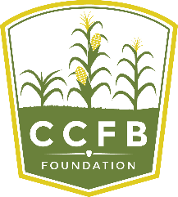
Application for Scholarship
2019 -2020 Academic Year
Recommendation
Please provide this form to a current instructor, coach, employer or mentor who can speak to your academic performance, peer relationships, community service and school involvement. This individual should not be related to the applicant. A form can be emailed to each of two references: individual forms can be found at www.ccfbfoundation.com. A completed application will include two recommendations.
Completed recommendation forms should be sent via email to Foundation Executive Director Kirk Builta at kirk@ccfarmbureau.com no later than February 1, 2019.

Student/Applicant Name:

Reference Name: Reference Email:

Organization: Position/Title:

- Please describe your relationship with the applicant.

- How would you describe this student’s character?

- Describe this student’s interaction with his/her peers.

- Please describe this student’s, maturity, motivation and communication skills.

Please Contact the Champaign County Farm Bureau Foundation with any questions:
Kirk Builta, Executive Director
801 N. Country Fair Drive, Suite A
Champaign, IL 61821
kirk@ccfarmbureau.com
Office: (217) 352-5235
Cell: (217) 621-5405

