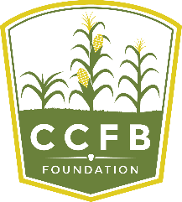
Application for Scholarship
2020 - 2021 Academic Year
Recommendation
Please provide this form to a current instructor, coach, employer or mentor who can speak to your academic performance, peer relationships, community service and school involvement. This individual should not be related to the applicant. This form can be emailed to each of two references: individual forms can be found at www.ccfbfoundation.com.
A completed application will include two recommendations.
Completed recommendation forms should be sent via email to Foundation Executive Director Kirk Builta at kirk@ccfarmbureau.com no later than January 31, 2020.

Student/Applicant Name:

Reference Name: Reference Email:

Organization: Position/Title:

- Please describe your relationship with the applicant.

- How would you describe this student’s character?

- Describe this student’s interaction with his/her peers.

- Please describe this student’s, maturity, motivation and communication skills.

Please Contact the Champaign County Farm Bureau Foundation with any questions:
Kirk Builta, Executive Director
801 N. Country Fair Drive, Suite A
Champaign, IL 61821
kirk@ccfarmbureau.com
Office: (217) 352-5235
Cell: (217) 621-5405

